**Programm 1:-** **write a java program to find a duplicate elements in an array**

**package** javavar;

**public** **class** FindDuplicateElements {

**public** **static** **void** main(String[] args) {

**int**[] array = **new** **int**[]{2, 4, 7, 2, 11, 5, 7, 14, 22, 11, 49, 58, 14, 101, 1, 3, 205, 49, 101, 12};

**for** (**int** i = 0; i < array.length; i++) { // outer loop

**for** (**int** j = i + 1; j < array.length; j++) { // inner loop

**if** (i != j && array[i] == array[j]) {

System.***out***.println("Duplicate element found:" + array[i]);

}

}

}

}

}

**Output-**Duplicate element found:2

Duplicate element found:7

Duplicate element found:11

Duplicate element found:14

Duplicate element found:49

Duplicate element found:101

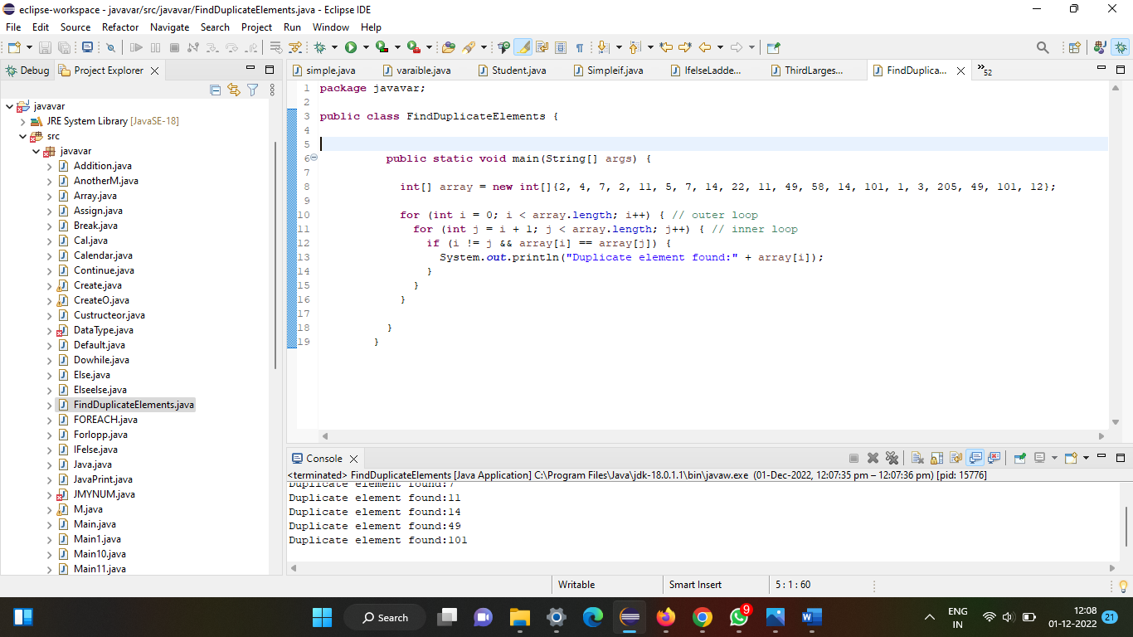

**Programm2-write to java pgm to find second largest num**

**package** javavar;

**public** **class** ThirdLargestNumberInAnArray {

**public** **static** **void** main(String args[]){

**int** temp, size;

**int** array[] = {10, 20, 25, 63, 96, 57};

size = array.length;

**for**(**int** i = 0; i<size; i++ ){

**for**(**int** j = i+1; j<size; j++){

**if**(array[i]>array[j]){

temp = array[i];

array[i] = array[j];

array[j] = temp;

}

}

}

System.***out***.println("second largest number is:: "+array[size-1]);

}

}

OUTPUT=

second largest number is:: 96

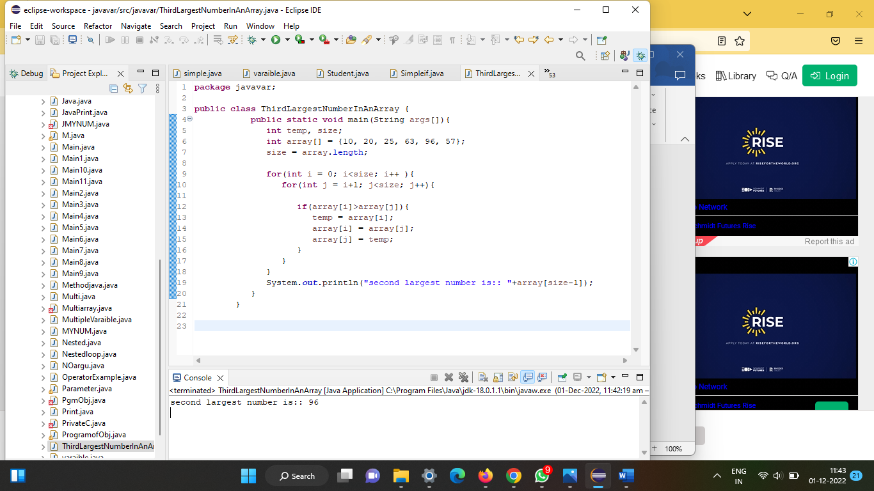

Program3:-write a java program to find a missing number in an array.

**package** javavar;

**public** **class** Exercise23 {

**static** **void** equality_checking_two_arrays(**int**[] my_array1, **int**[] my_array2)

{

**boolean** equalOrNot = **true**;

**if**(my_array1.length == my_array2.length)

{

**for** (**int** i = 0; i < my_array1.length; i++)

{

**if**(my_array1[i] != my_array2[i])

{

equalOrNot = **false**;

}

}

}

**else**

{

equalOrNot = **false**;

}

**if** (equalOrNot)

{

System.***out***.println("Two arrays are equal.");

}

**else**

{

System.***out***.println("Two arrays are not equal.");

}

}

**public** **static** **void** main(String[] args)

{

**int**[] array1 = {2, 5, 7, 9, 11};

**int**[] array2 = {2, 5, 7, 8, 11};

**int**[] array3 = {2, 5, 7, 9, 11};

*equality_checking_two_arrays*(array1, array2);

*equality_checking_two_arrays*(array1, array3);

}

}

OUTPUT=Two arrays are not equal.

Two arrays are equal.

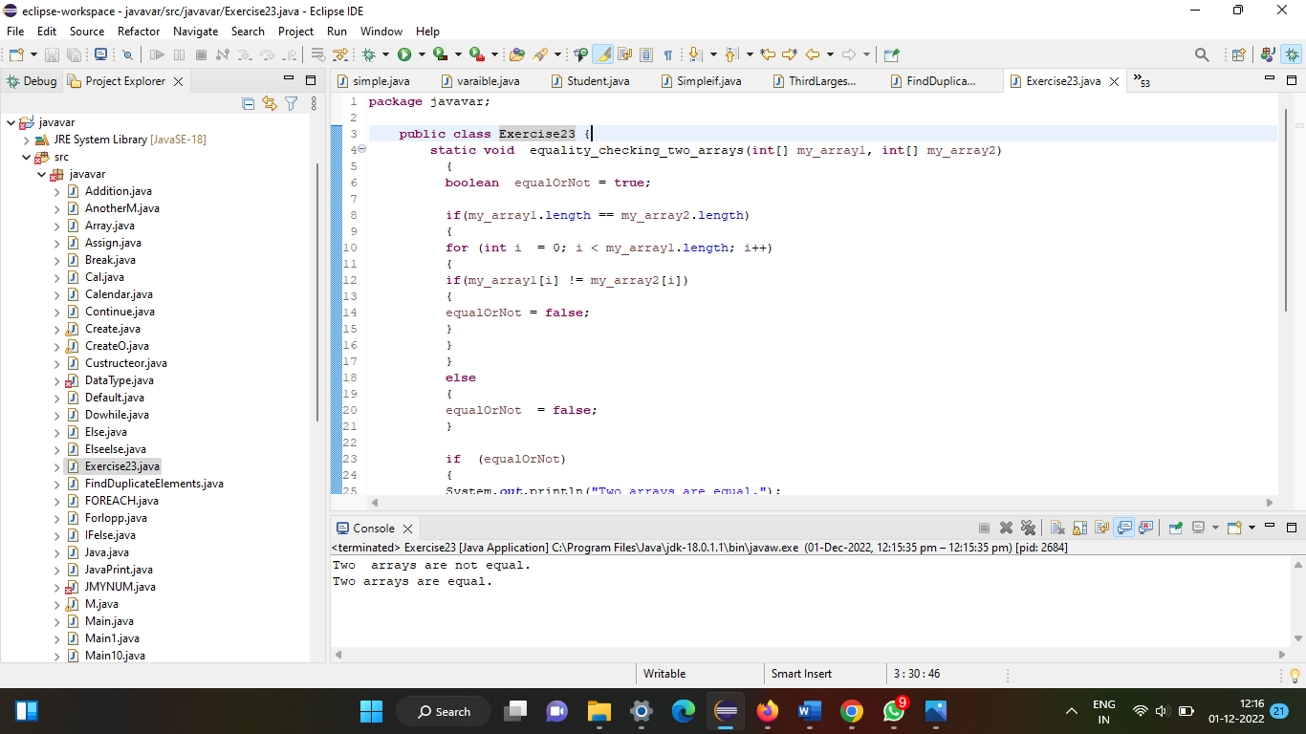

Programm4:-write a java programm to find all pair of element in integer array whose sum is equal to a given number

**package** javavar;

**import** java.util.Arrays;

**import** java.util.Scanner;

**public** **class** Sample {

**public** **static** **void** main(String args[]){

//Reading the array from the user

Scanner sc = **new** Scanner(System.***in***);

System.***out***.println("Enter the size of the array that is to be created: ");

**int** size = sc.nextInt();

**int**[] myArray = **new** **int**[size];

System.***out***.println("Enter the elements of the array: ");

**for**(**int** i=0; i<size; i++){

myArray[i] = sc.nextInt();

}

//Reading the number

System.***out***.println("Enter the number: ");

**int** num = sc.nextInt();

System.***out***.println("The array created is: "+Arrays.*toString*(myArray));

System.***out***.println("indices of the elements whose sum is: "+num);

**for**(**int** i=0; i<myArray.length; i++){

**for** (**int** j=i; j<myArray.length; j++){

**if**((myArray[i]+myArray[j])== num && i!=j){

System.***out***.println(i+", "+j);

}

}

}

}

}

OUTPUT=

Enter the size of the array that is to be created:

8

Enter the elements of the array:

15

12

4

16

9

8

24

0

Enter the number:

24

The array created is: [15, 12, 4, 16, 9, 8, 24, 0]

indices of the elements whose sum is: 24

0, 4

3, 5

6, 7

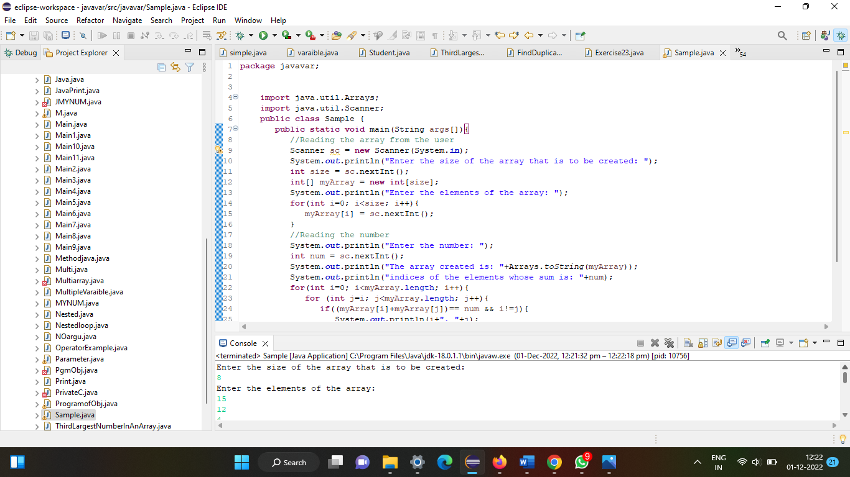

Program5:-write a java prtogramm to find continuous sub array whose sum is equal to given number

**package** javavar;

**import** java.util.Arrays;

**import** java.util.Scanner;

**public** **class** sub_arrays {

**public** **static** **void** main(String args[]){

//Reading the array from the user

Scanner sc = **new** Scanner(System.***in***);

System.***out***.println("Enter the size of the array that is to be created: ");

**int** size = sc.nextInt();

**int**[] myArray = **new** **int**[size];

System.***out***.println("Enter the elements of the array: ");

**for**(**int** i=0; i<size; i++){

myArray[i] = sc.nextInt();

}

//Reading the number

System.***out***.println("Enter the required sum: ");

**int** reqSum = sc.nextInt();

System.***out***.println("The array created is: "+Arrays.*toString*(myArray));

System.***out***.println("sub arrays whose sum is: "+reqSum);

**for**(**int** i=0; i<myArray.length; i++){

**int** sum = 0;

**for** (**int** j=i; j<myArray.length; j++){

sum = sum + myArray[j];

**if**(sum == reqSum){

System.***out***.println(Arrays.*toString*(Arrays.*copyOfRange*(myArray, i, j+1)));

}

}

}

}

}

Output=

Enter the size of the array that is to be created:

10

Enter the elements of the array:

5

4

1

2

3

4

1

2

4

5

Enter the required sum:

10

The array created is: [5, 4, 1, 2, 3, 4, 1, 2, 4, 5]

sub arrays whose sum is: 10

[5, 4, 1]

[4, 1, 2, 3]

[1, 2, 3, 4]

[2, 3, 4, 1]

[3, 4, 1, 2]

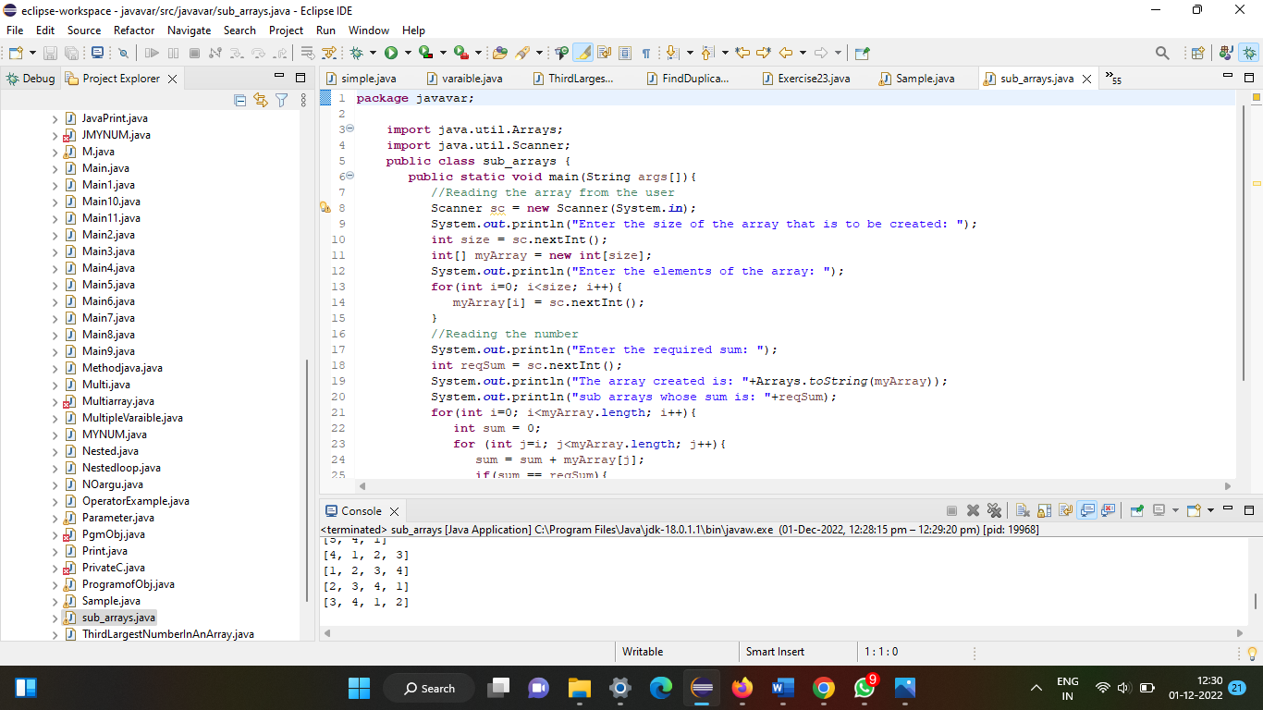

Programm6:-write a java programm to find insertion of two array

**package** javavar;

**public** **class** IntersectionOfTwoArrays {

**public** **static** **void** main(String args[]) {

**int** myArray1[] = {23, 36, 96, 78, 55};

**int** myArray2[] = {78, 45, 19, 73, 55};

System.***out***.println("Intersection of the two arrays ::");

**for**(**int** i = 0; i<myArray1.length; i++ ) {

**for**(**int** j = 0; j<myArray2.length; j++) {

**if**(myArray1[i]==myArray2[j]) {

System.***out***.println(myArray2[j]);

}

}

}

}

}

Intersection of the two arrays ::

78

55

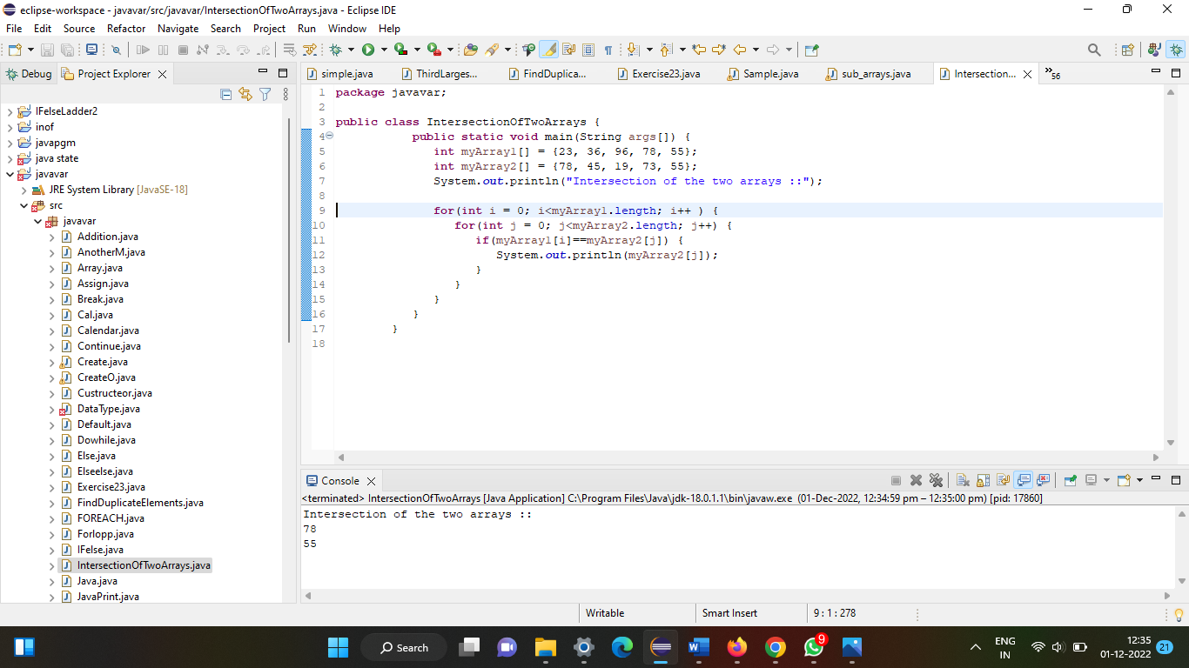

Programm7:-write a java programm to seprate zeroes from non zeroes in an interger arra

**package** javavar;

**import** java.util.Arrays;

**import** java.util.Scanner;

**public** **class** ZerosFromNonZeros {

**public** **static** **void** main(String args[]){

//Reading the array from the user

Scanner sc = **new** Scanner(System.***in***);

System.***out***.println("Enter the size of the array that is to be created: ");

**int** size = sc.nextInt();

**int**[] myArray = **new** **int**[size];

System.***out***.println("Enter the elements of the array: ");

**for**(**int** i=0; i<size; i++){

myArray[i] = sc.nextInt();

}

System.***out***.println("The array created is: "+Arrays.*toString*(myArray));

System.***out***.println("Resultant array: ");

**int** pos = 0;

**for**(**int** i=0; i<myArray.length; i++){

**if**(myArray[i]!=0){

myArray[pos]=myArray[i];

pos++;

}

}

**while**(pos<myArray.length) {

myArray[pos] = 0;

pos++;

}

System.***out***.println("The array created is: "+Arrays.*toString*(myArray));

}

}

Output=

Enter the size of the array that is to be created:

8

Enter the elements of the array:

14

0

56

0

12

47

0

0

The array created is: [14, 0, 56, 0, 12, 47, 0, 0]

Resultant array:

The array created is: [14, 56, 12, 47, 0, 0, 0, 0]

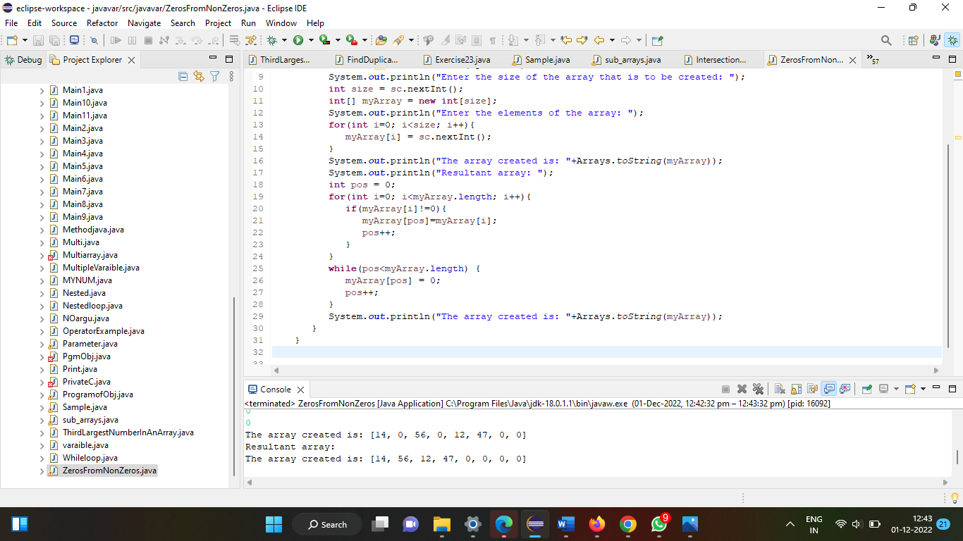

Programm8:-write a java programm to convert array to arraylist and an arraylist to array

**package** javavar;

**import** java.util.ArrayList;

**import** java.util.Arrays;

**public** **class** Exercise29 {

**public** **static** **void** main(String[] args)

{

String[] my_array = **new** String[] {"Rijwana", "usha", "anjli", "roshni", "myuri", "chatu"};

ArrayList<String> list = **new** ArrayList<String>(Arrays.*asList*(my_array));

System.***out***.println(list);

}

}

Output=

[Rijwana, usha, anjli, roshni, myuri, chatu]

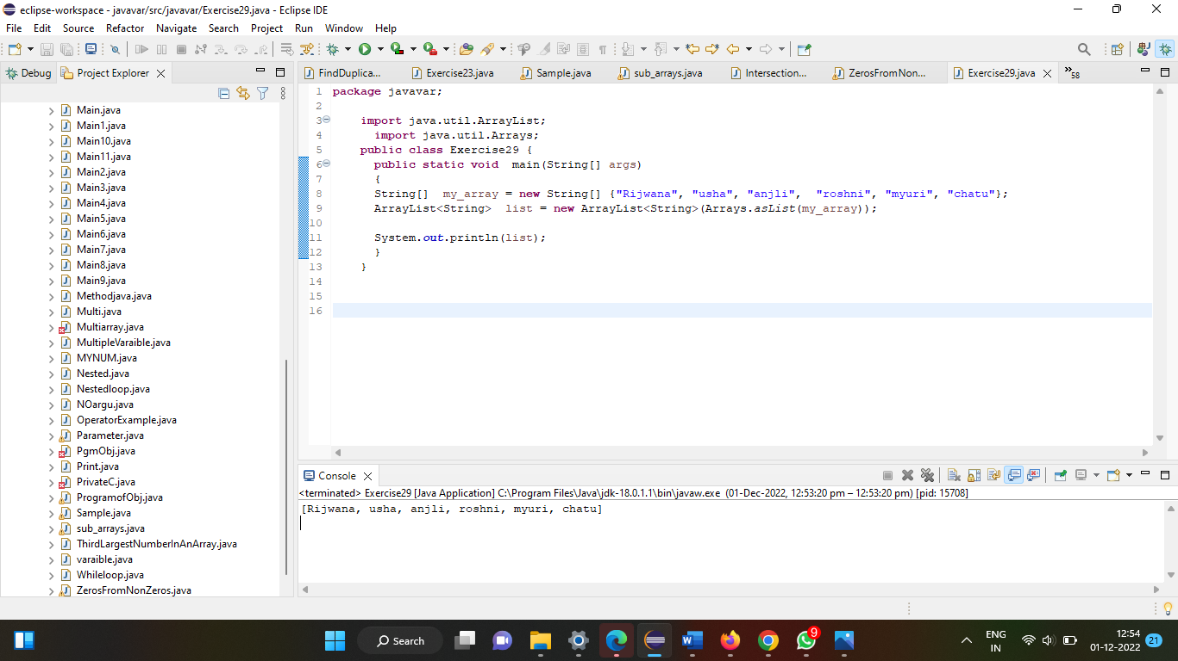

Programm9:- write a java program to count occurrences of each element in an array

**package** javavar;

**import** java.util.Scanner;

**public** **class** Count_Occurrence

{

**public** **static** **void** main(String[] args)

{

**int** n, x, count = 0, i = 0;

Scanner s = **new** Scanner(System.***in***);

System.***out***.print("Enter no. of elements you want in array:");

n = s.nextInt();

**int** a[] = **new** **int**[n];

System.***out***.println("Enter all the elements:");

**for**(i = 0; i < n; i++)

{

a[i] = s.nextInt();

}

System.***out***.print("Enter the element of which you want to count number of occurrences:");

x = s.nextInt();

**for**(i = 0; i < n; i++)

{

**if**(a[i] == x)

{

count++;

}

}

System.***out***.println("Number of Occurrence of the Element:"+count);

}

}

output=

Enter no. of elements you want in array:5

Enter all the elements:

2

3

3

4

5

Enter the element of which you want to count number of occurrences:3

Number of Occurrence of the Element:2

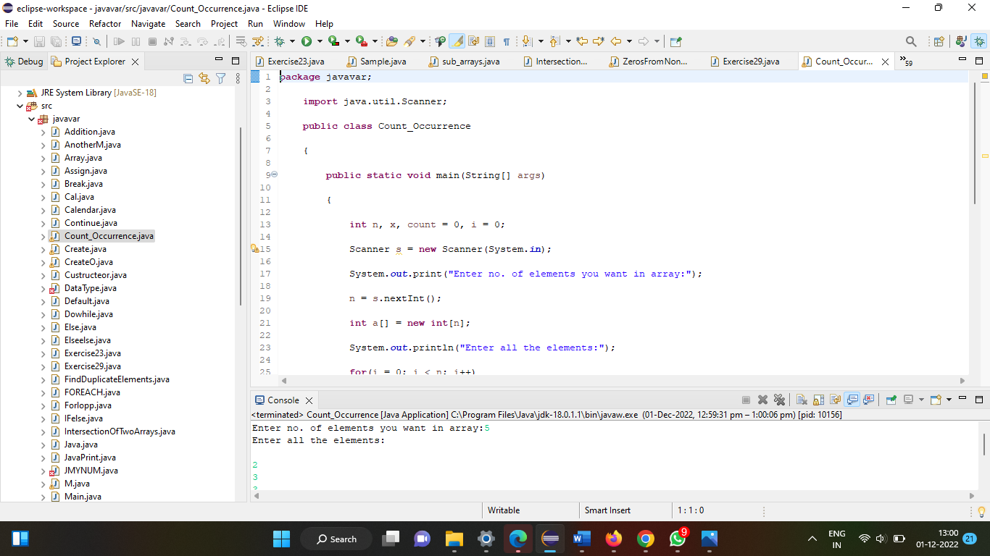

Programm 10:- write a java programm to reverse an array without using an additional array

**package** javavar;

**public** **class** ReverseArrayWithoutAnotherArray {

**public** **static** **void** main(**final** String[] args) {

**final** **int**[] array = { 1, 2, 3, 4, 5, 6, 7, 8, 9, 10 };

**final** **int** middle = array.length / 2;

**int** temp;

**int** j = array.length -1;

**for**(**final** **int** a : array){

System.***out***.println(" before reverse :: " + a);

}

**for** (**int** i = 0 ; i < middle; i++, j--) {

temp = array[i];

array[i] = array[j];

array[j] = temp;

}

**for**(**final** **int** a : array){

System.***out***.println(" after reverse :: " + a);

}

}

}

Output=

before reverse :: 1

before reverse :: 2

before reverse :: 3

before reverse :: 4

before reverse :: 5

before reverse :: 6

before reverse :: 7

before reverse :: 8

before reverse :: 9

before reverse :: 10

after reverse :: 10

after reverse :: 9

after reverse :: 8

after reverse :: 7

after reverse :: 6

after reverse :: 5

after reverse :: 4

after reverse :: 3

after reverse :: 2

after reverse :: 1

